**3rd Wave of Corona -Nothing to worry**

**By Prof. NV RA Raja,**

**Meena2 Jr. Chairman, JKR Astro Research Foundation**

**How Eclipse -Gochara/Transit of Planets and the Sun affects a country’s Prospects-  
Analysis based on Vedic astrology**

**Jai Meena2.**

**Wishing you all a happy and blessed Guru Poornima.**

We all know that mundane astrology is a study of macroscopic influences of planets and stars on mankind or the beings on the earth. We can boldly say samithas like NARADA Samitha, Kasyapa Samitha ,Garga Samitha and Brihat Samitha of Varaha Mihira are very authentic in giving surtras and methods for analyzing mundane matters. With the help of Mundane astrology we can analyze the events affect destiny of mankind in any manner like outbreak of wars, earthquake, floods, droughts famines, revolutions, epidemics like corona, heavy rainfalls, increase in national crime rates and death mortality etc.

In mundane astrology, we study the how natural or unnatural events effect a country or the world. Application of above said great rishis mundane principles may help us assess mundane situations well in advance.

We all knew that Varaha Minira, Parasara, Garga rishi, Kashyapa muni had assigned planets and Nakshatras to various states and sub continents and foreign countries.

|  |  |
| --- | --- |
| **Planet and combinations** | **Affecting areas** |
| The Sun’s and Planetary rays | Psychological and biological |
| Combination of the Sun and The Moon | Sea water and fluids on the surface of earth |
| Sun spots activity | Calamities like famine and drought and rainfall and epidemics |
| Transit of planets | Thought process of human being |
| Solar variations | Health, business activities, human behaviour |
| Suns ingress | National events, health and business activities |
| Solar and Lunar Eclipses | Natural calamities, accidents, epidemic, change in behavior of people, ruling class or governments |
| Magnetic storms | Satellites, shot wave radio receptions |
| Astroids-meteorological conditions | Fire and explosions |
| Appearance of Comets | Wars,epidemic,earthquaks,death of head of a country |
|  |  |

**Influence of Bhavas on the chart**

* First House- Attitude. Common people General conditions Public health
* Second house- Country’s economy. Revenue generations
* Third house- Mood of the people, Not conducive for spending
* Sixth house –Public health, Vaccination programme Lifesaving services
* Eighth House- Death, Epidemic calamity. Pandemic
* Eleventh House- Positive approach
* Twelfth House- Hospital, General health. Disease. Sufferings and anxiety

In this article, I have linked India’s independence chart with Solar eclipase and Sri Sarvari and Sri Pilava Varusha Jagat Kundali. Influence of Jagat lagna on india and other countries. You can just observe that Independence chart and Republic chart have Rahu and Ketu in Lagna and 7th house. This indicate that our country may face many ups and downs in the process of growing or achieving what it want I the world. As per the position of lagna in the natural second house and finance house connected the natural third house indicate entire India’s prospects and area’s of concern will be on Revenue, finance, wealth of people, national wealth, trade commerce, banking monetary fiscal conditions, allies, communication, transport, newspapers, journals, press, neighbouring countries etc.

India’s Independence/Republic day Charts

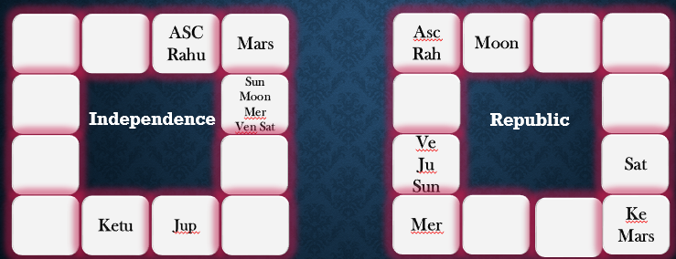

**Impact of Solar Eclipse 21-6-2020**

The follwing chrt is linked with Eclipse of Sri Sarvari Varusha- here we can notice that eclipse happened in Idias Second house that is inGemini. Generaly effect of eclipse on nation will be for atleast 13 to 15 months from the date of eclise month. We can take one or two months earlier to feel the effects. During June 2020 eclipse in Gemini and we felt the effect two months earlier to June. Even today efects we are watching. Lockdown, corona death mortality, general public’s bank balanace is vanishing due to medical needs, Governmetn revenue collapsed, Industries are not doing well , trade and commerce issues, banks facing problems etc. all narrowed down to second house from lagna. Then while watching from natural third house gemini, we are facing a big hit on transport, tourism,hotel and textiles and facing problem with china on border issues. Our Varahamihira and Parasara Maharishis were great theergadharsis in forecasting what is in store for a country or human being. Eclipse on the natal Mars agrrevatd death morality and sudden deaths due to corona pandemic. Since we are approaching 14 moths period from the last eclipse date, we can surely expect releif from the pandemic and everyones positon may improve.

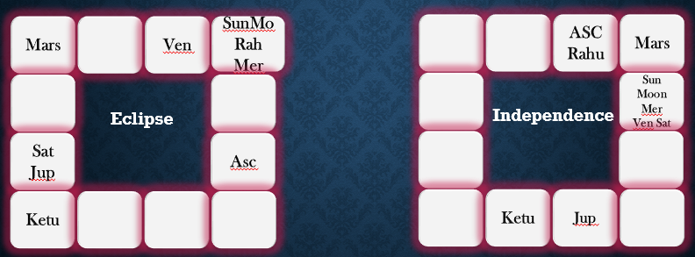

Jagat Kundali Charts of Sri Sarvari and Sri Pilava of 2020 and 2021

Let us analyze how Jagat Kundali of Sri Sarvari and Sri Pilava impacting our normal life. Sri Sarvari Varusha started with Libra Lagna, which is 6th to Indias lagna and from Libra India’s lagna is 8th. Jagat lagnathipathi had gone to 8th house and aspect of Saturn on Jagat lagna. Conjunction of Mars Jupiter and Saturn in Capricorn from the jagat laga 4th house. This conjunctions had spoiled activities linked to educational institutions, students, and landed property general happiness of the people. We all know that how much we all had suffered and how we are trying to overcome the effect of this combination in Capricorn.

Now let us analyse this Sri Pilava varusha Jagat Kundali, Here lagna is Capricorn, which is 9th from Indian lagna . Saturn in the lagna and Jupiter in Second house and Mars in sixth house, this position shows hope and promising trend to us to overcome the pandemic effect. General public may work hard and try to earn more money and focus on work to overcome the financial adversity faced in Sri Sarvari varusha. Comfortable positon of planets in Aries from Jagat Kundali also promises good progress, health improvement, good agricultural production, good rain general happiness and possibility of educational institutions opening for students and conducting of exams on time are possible.

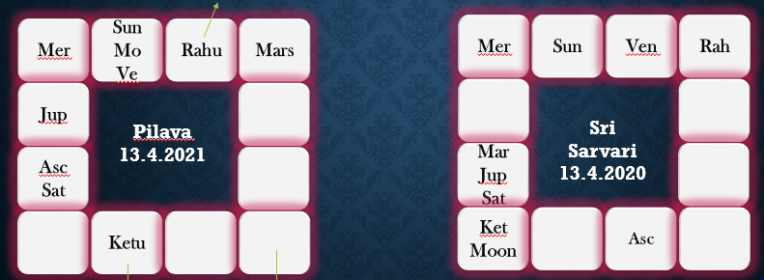

Sun’s Ingress

While analyzing from Sun’s ingress chart, a bright prospects are indicated. We had suffered during May and June. But Dakshinaya punya kala ingress chart shows a good recovery trend and also possibility of not much effect on 3rd wave of corona on Indian public. No native aspect on the lagna and favourable positon of Moon indicate that from mid July/ Mid August, we can notice that in all activities normalcy may return. Since Ketu in lagna and also in natural 8th house may cause hesitation among public to move freely and spend money liberally. Government of India’s vaccination programme may see a grand success and many people may get vaccinated. Health of general public will improve and also planetary combination shows that good immunity system may develop among people.

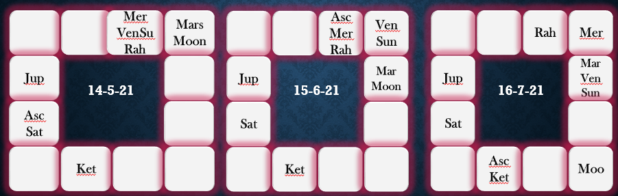

While concluding this article, I would like to emphasis all astro students to focus on eclipse and Jagat Kundali and Sun’s monthly ingress chart to analyse mundane maters of a country or world. The Sun is the main source of energy and the prime monitor of all activities of the Solar Kingdom. We are living on the earth is a part of it. Monitor transit of major planets like Saturn and Jupiter, link them with Jagat and Suns ingress chart to arrive probable events likely to happen.

We pray to all 18 siddhas and Guruji Sri Raghavachary to protect us from this corona pandemic and give excellent health and wealth.